🧠 Convolutional Neural Networks (CNNs) – Complete Guide
https://medium.com/@draj0718/convolutional-neural-networks-cnn-architectures-explained-716fb197b243

  - ANN's Approach for Image Classification:
    - A 28x28 image is flattened into a 1D vector, resulting in 784 input values (28 * 28 = 784).
    - These inputs are fed into the input layer, followed by fully connected hidden layers.
    - Finally, there's an output layer, typically a Softmax layer.
  - CNN's Approach for Image Classification:
    - CNNs use the image in its original 2D form.
    - Filters (e.g., 3x3) are applied to the image.
    - This process generates a feature map (e.g., a 26x26 map from a 28x28 input using a 3x3 filter).
    - A ReLU activation function is applied to the feature map.
    - A pooling layer (e.g., max pooling) is then used.
    - The output is then flattened.
    - The flattened output is sent to a fully connected layer.
    - Finally, there's a Softmax layer for the output.

ANN Disadvantage: If an input image size increases (e.g., from 28x28x3 to 1080x1080x3), the number of input nodes in an ANN would increase dramatically. This leads to a proportional increase in weights between the input layer and the first hidden layer (calculated as input units * hidden units).
    - For large images, this means ANNs will have millions of weights, resulting in slow training, high computational costs, and an increased chance of overfitting.
    - CNN Advantage: The architecture of CNNs ensures that the number of weights remains constant regardless of the input image size, leading to lower computational cost and reduced overfitting risk.

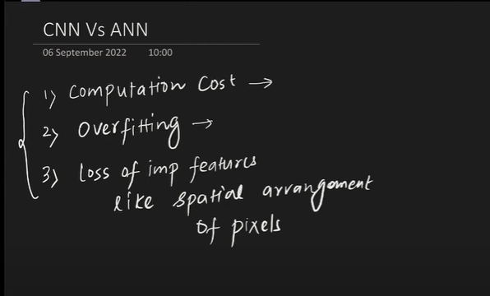

Why CNNs are Necessary (Problems with ANNs on Image Data)
While ANNs can be used for image classification (e.g., achieving about 98% accuracy on the MNIST handwritten digits dataset), CNNs consistently perform better. The primary reasons why ANNs are not ideal for image data are:
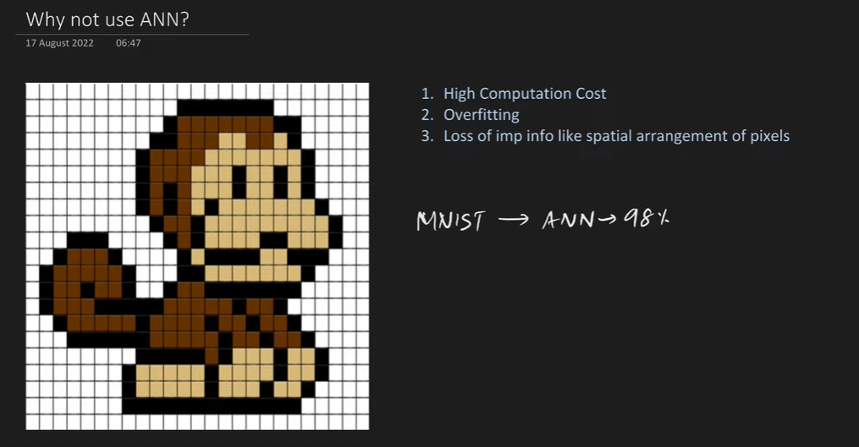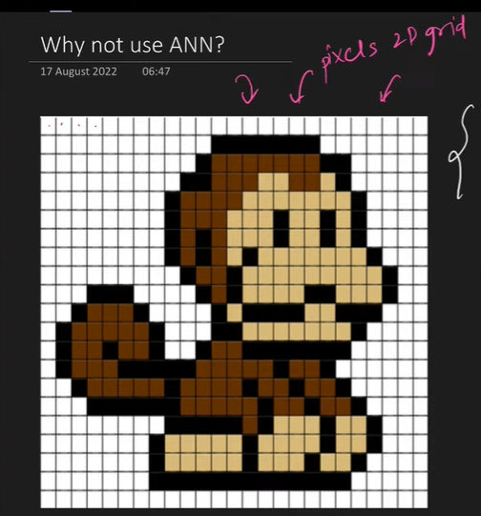
- High Computational Cost:
  - Image Structure: An image is essentially a 2D grid of pixels.
  - ANN Input Requirement: For an ANN, this 2D image must be flattened into a 1D array of numbers. For example, a 40x40 pixel image has 1600 pixels, which become 1600 numbers in a 1D array.
  - Weight Explosion: When these 1D pixels are connected to a fully connected hidden layer, the number of weights becomes extremely large.
    - Example: For a small 40x40 pixel image (1600 pixels) connected to a modest hidden layer with 100 units, the number of weights in just the first layer would be 1600 * 100 = 160,000 weights.
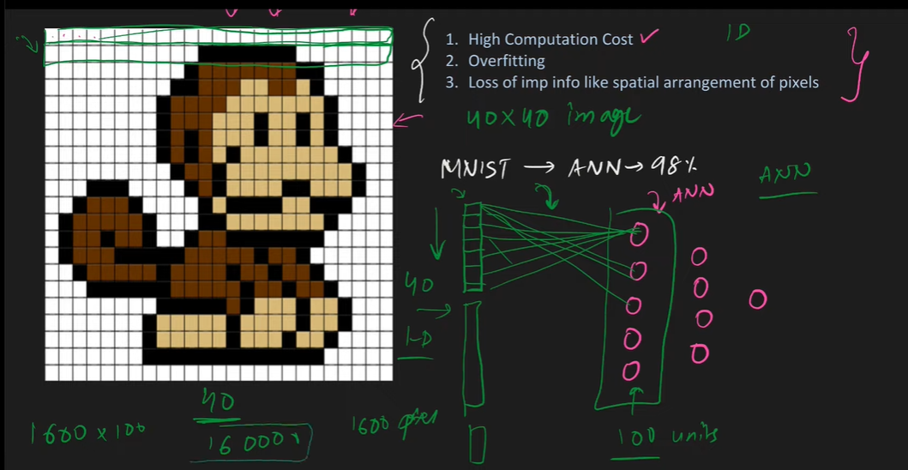
  - Consequence: As image sizes increase (e.g., 1000x1000 pixels) or the number of hidden units grows, the number of weights can reach millions or billions, leading to immense computational costs and significantly longer training times.
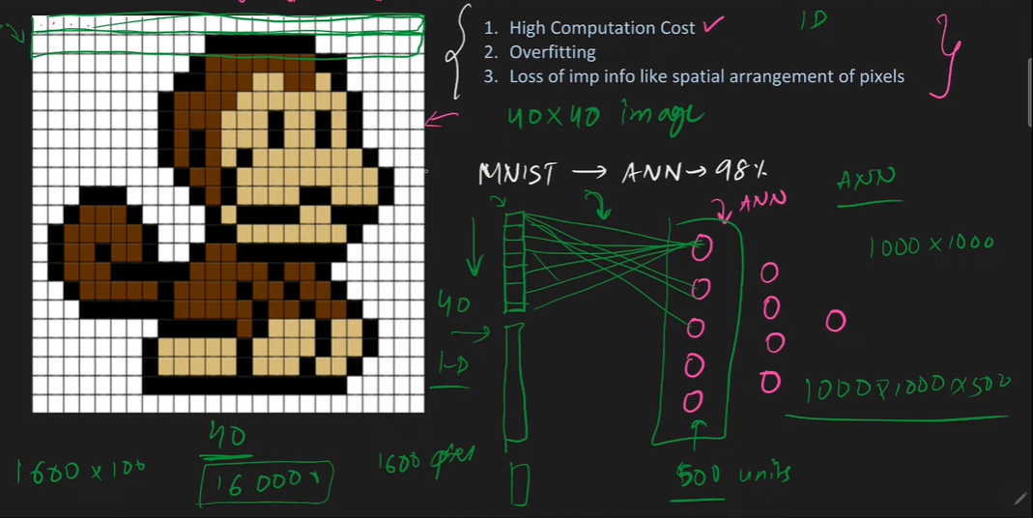
- Overfitting:
  - By connecting every single pixel to every node in the subsequent layer, an ANN attempts to learn and capture every minute pattern in the image, no matter how insignificant.
  - Consequence: This exhaustive learning often leads to overfitting, where the model performs exceptionally well on the training data but fails to generalize and performs poorly on new, unseen test data.
- Loss of Spatial Arrangement:
  - Crucial Features: The spatial arrangement and relationships between pixels (e.g., the distance and relative position of a monkey's eye and nose) are very important features for identifying objects in an image.
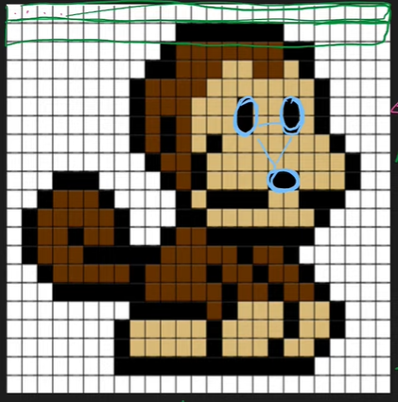
  - Flattening Issue: When a 2D image is converted into a 1D array for an ANN, this critical spatial context and arrangement are completely lost.
  - Consequence: The loss of these inherent 2D features severely hampers the ANN's ability to effectively classify images, leading to less accurate results compared to CNNs.

1. 🔎 Introduction
A Convolutional Neural Network (CNN) is a type of deep learning model specifically designed to process data with a grid-like topology, such as:
- Images (2D grid of pixels)
- Videos (sequence of image frames)
- Audio (1D grid of waveforms)
👉 CNNs are the backbone of computer vision tasks like object detection, face recognition, and medical image analysis.

Inspiration Behind CNN and Parallels With The Human Visual System

Flow Summary: Light -> Retina -> Optic Nerves -> Lateral Geniculate Nucleus (LGN, for pre-processing) -> Primary Visual Cortex (V1).

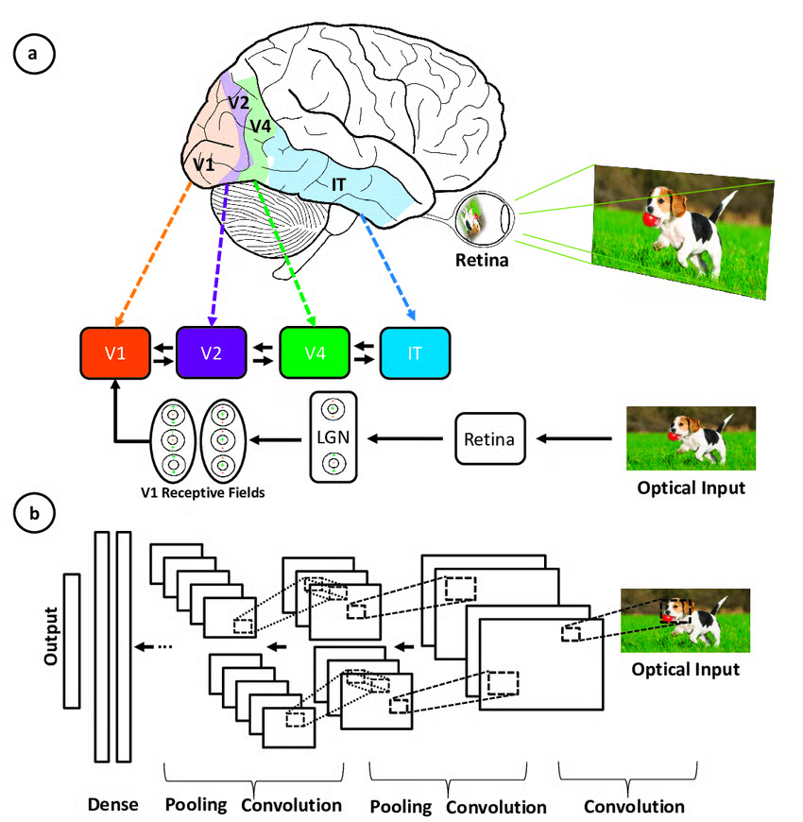
biological connection of Convolutional Neural Networks (CNNs) to the human visual cortex. The architecture of CNNs is inspired by our own visual cortex, which is a part of our brain.

The Hubel and Wiesel Experiment (The Famous Cat Experiment)
This section describes a pivotal experiment conducted by Hubel and Wiesel around the 1960s.

  - The visual cortex is structured such that simple cells detect basic features (like edges), and then complex cells combine these basic features to detect more complex patterns.

Connection to Convolutional Neural Networks (CNNs)
The principles discovered from the Hubel and Wiesel experiments became a significant inspiration for computer scientists.
- Modern CNNs
  - Yann LeCun (1990s): He developed his own CNN architecture in the 1990s.
  - Key Components: His architecture incorporated backpropagation and pooling layers.
  - Application: This model was highly effective for scanning checks.
  - Significance: This marked the beginning of serious research into CNNs.
  - AlexNet (2012): A significant breakthrough occurred in 2012 when AlexNet won the ImageNet competition, showcasing the power of CNNs.
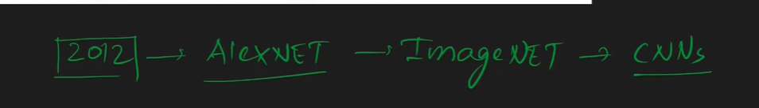
  - Further Developments: Since then, many other CNN architectures have emerged and are continuously being developed.

2. 🎯 Why CNNs?
- Traditional fully connected neural networks (MLPs) treat each pixel as independent → lose spatial relationships.
- Images are high-dimensional; feeding raw pixels into MLPs leads to huge parameter counts.
- CNNs preserve spatial relationships (edges, shapes, objects) and drastically reduce parameters by weight sharing.

6. How CNNs Work: Intuition and Feature Extraction
CNNs approach image classification by mimicking how the human brain identifies objects.
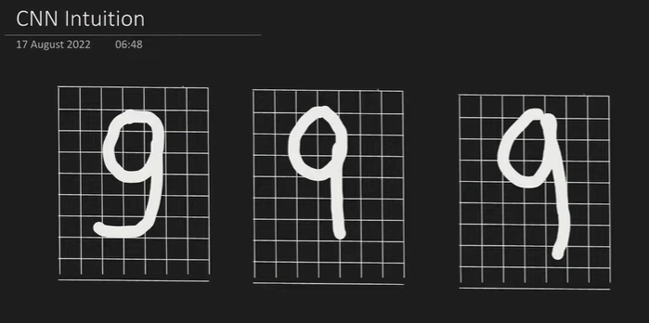
- Human Brain Analogy:
  - Consider classifying the digit '9'. Our brain doesn't just see a whole '9'; it looks for specific patterns: a circle, a vertical line, and a horizontal line.
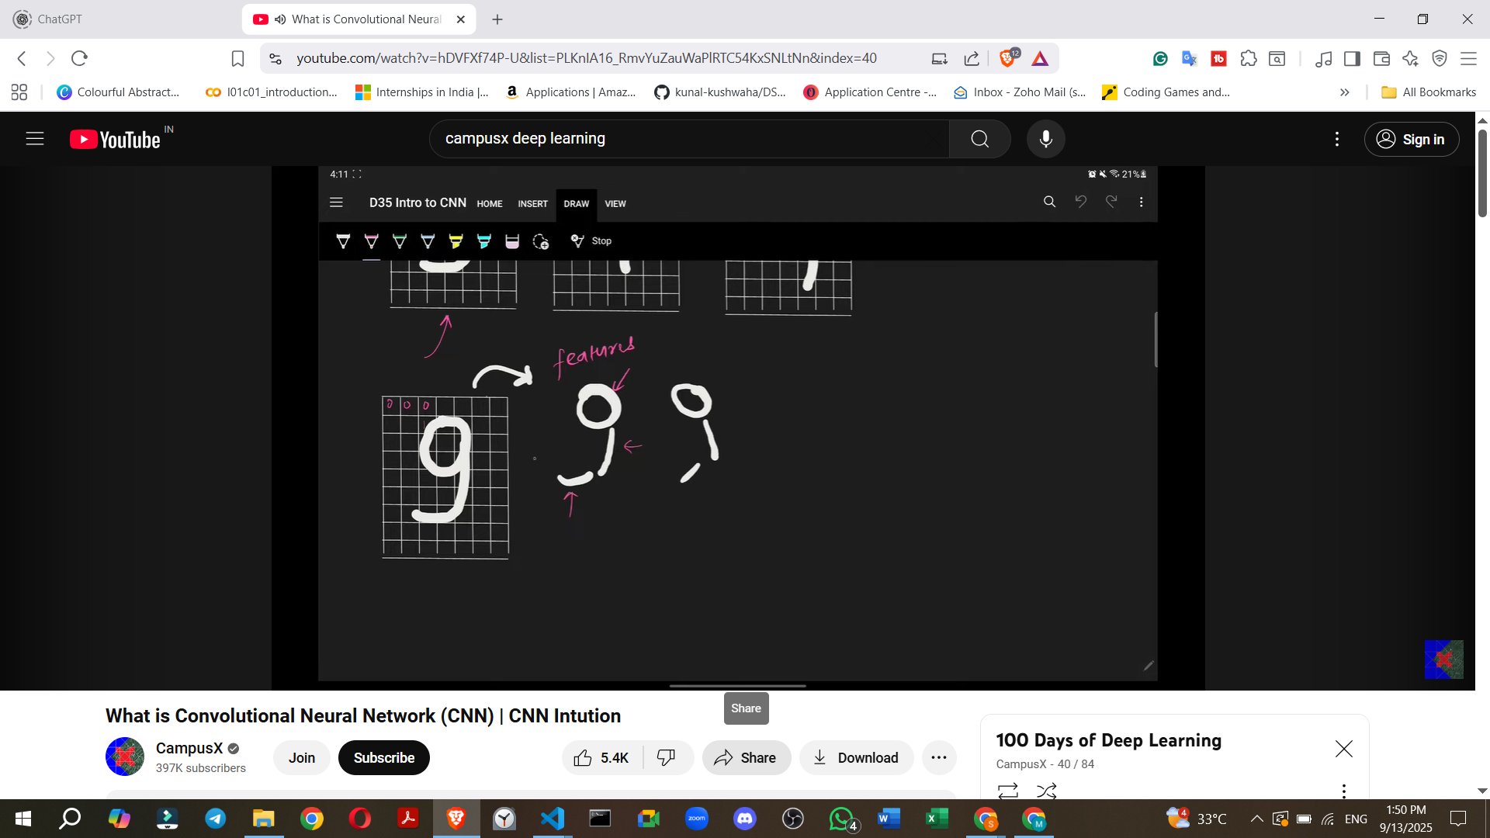
  - Even if these patterns are slightly distorted (e.g., a slightly imperfect circle or angled lines), our brain can still recognize the '9'.
  - This process involves breaking down the digit into its component features.
- CNN Mechanism:
  - Primitive Feature Extraction: When a CNN receives an image, its initial convolutional layers focus on extracting primitive features such as edges (horizontal, vertical, diagonal lines, corners).
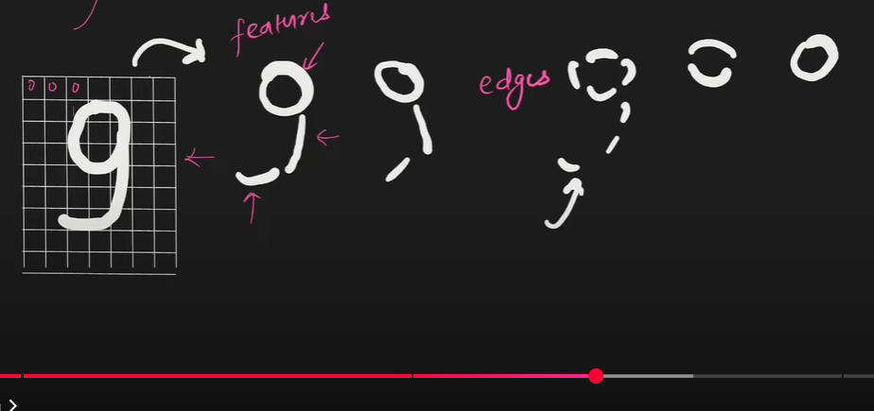
    - Example: For a '9', the CNN first identifies the basic edges that form the circle, the vertical stem, and the horizontal base.
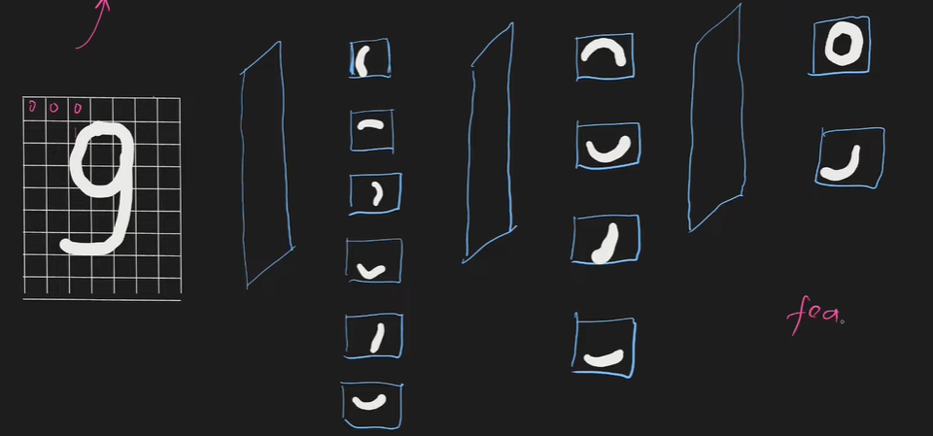
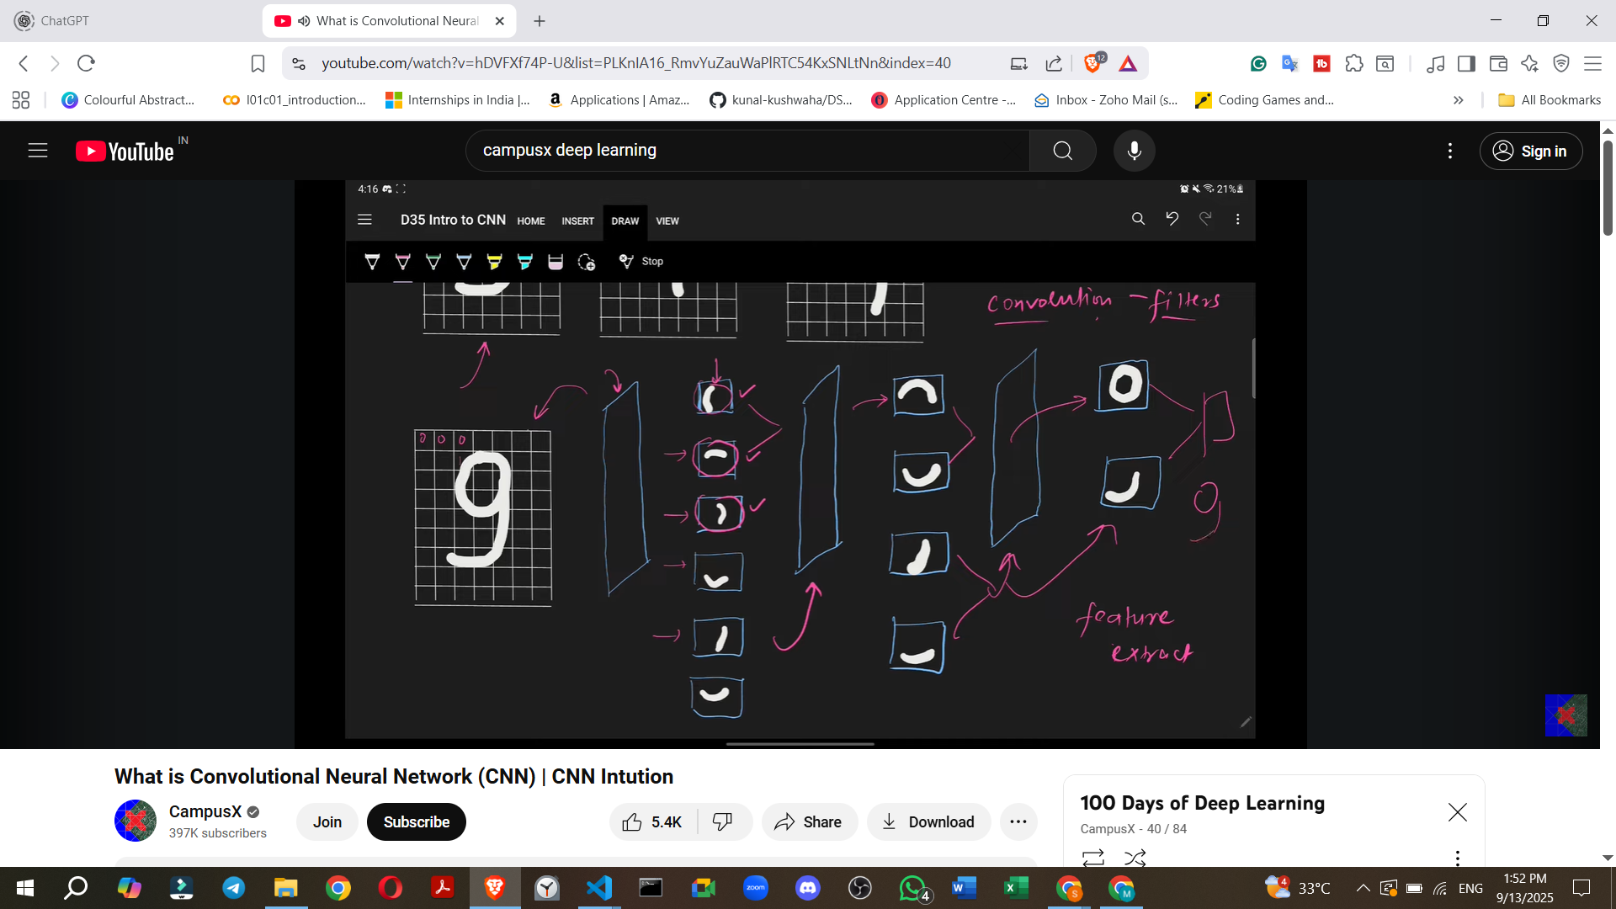
  - Filters/Kernels: Convolutional layers employ "filters" (also known as kernels). These are small matrices that "slide" or "move" across the input image.
    - The purpose of these filters is to detect specific patterns or features within the image.
    - When a filter matches a particular pattern (e.g., a vertical edge), that feature becomes "activated".
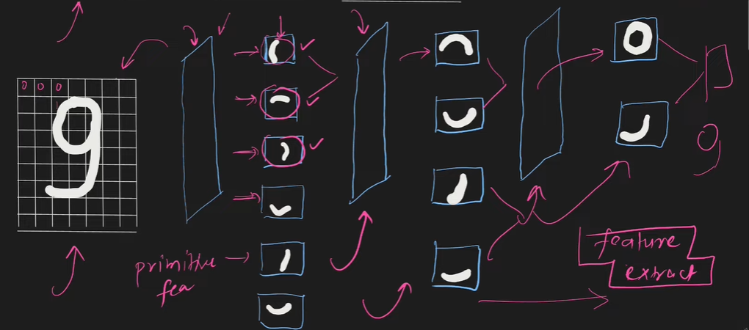
  - Building Complex Features:
    - The primitive features extracted by earlier layers are then passed to subsequent convolutional layers.
    - These deeper layers combine the simpler features to build more complex and meaningful features.
    - Example (Digit 9): Edges are combined to form semi-circles, which are then combined to form a full circle. Simultaneously, other edges are combined to form lines.
    - Example (Cat Image): Initial layers might detect simple edges. Middle layers would combine these edges to form more complex parts like ears, eyes, or a mouth. The deepest layers would then combine these parts to recognize a full face or body of a cat, allowing the CNN to classify the image as a "cat".
  - Deep Learning Principle: As the CNN gets progressively "deeper" (more layers), it extracts increasingly abstract and complex features, moving from primitive edges to high-level conceptual components, ultimately leading to accurate classification.

Convolution Operation: The Fundamental Building Block
The convolution operation is responsible for extracting features from an image.

Edge Detection: A common initial feature extracted by convolution layers is edges.
◦ What are Edges?: Edges represent a change in intensity within an image.
◦ Example: If an area of an image is black (low intensity) and then suddenly transitions to white (high intensity), that transition forms an edge.
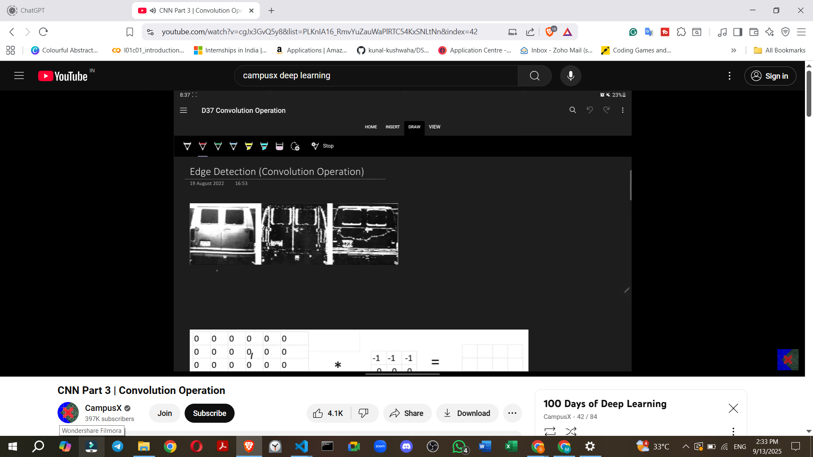

. Filter (Kernel): A small matrix of numbers, typically 3x3, used to detect specific features.
▪ Example (Horizontal Edge Detector Filter):
▪ This specific filter is designed to detect horizontal edges.

3. ⚙️ CNN Architecture Components
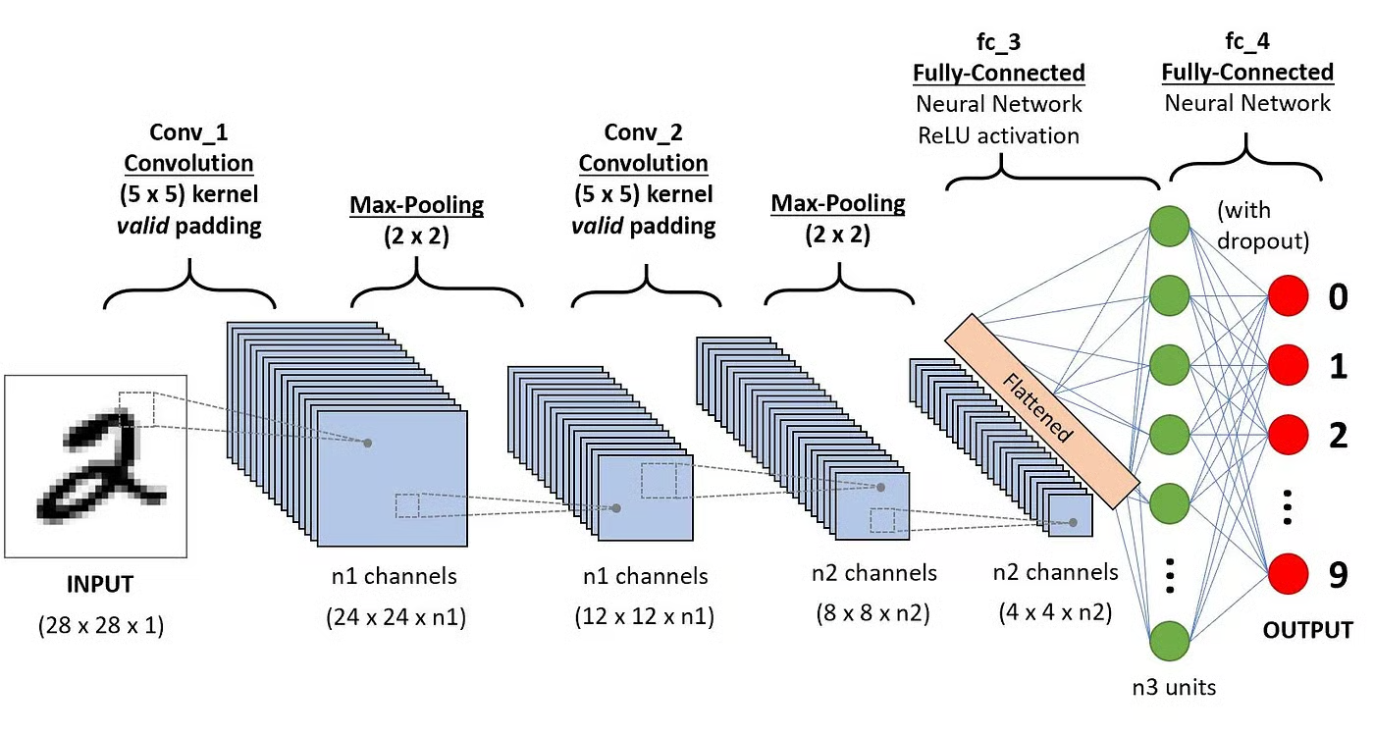
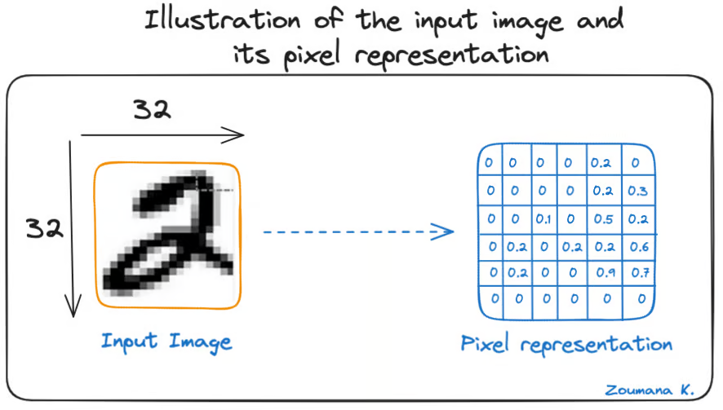
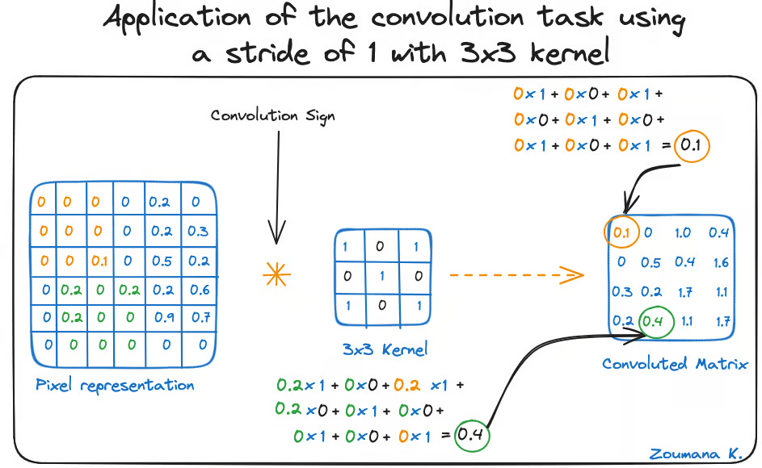

(a) Convolution Layer
- Core operation of CNN.
- Uses a filter (kernel) that slides across the input image.
  - https://deeplizard.com/resource/pavq7noze2
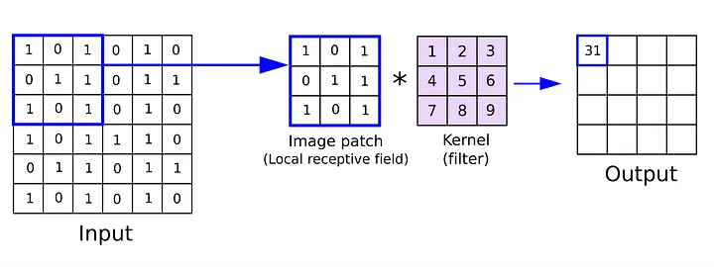
- Each filter detects a feature (edges, corners, textures, patterns).
- Formula for convolution (2D case):
[
S(i,j) = \sum_m \sum_n I(i+m, j+n) \cdot K(m,n)
]
where:
- (I) = input image
- (K) = kernel
- (S) = feature map (output)
👉 Weight sharing: same kernel applied across the whole image.
https://poloclub.github.io/cnn-explainer/

(b) Padding
- Adds extra pixels around image borders.
Need for Padding
- Before discussing padding, it's essential to understand why it's needed.
- When a filter is convolved over an image, the resulting feature map is smaller than the original image.
  - For example, a 5x5 image convolved with a 3x3 filter results in a 3x3 feature map.
- Problem 1: Reduction in Resolution/Information Loss
  - If multiple convolutional layers are applied consecutively, the image size will continuously decrease.
  - This leads to a loss of information with each layer, which is generally undesirable.
- Problem 2: Underrepresentation of Border Pixels
  - Pixels at the borders (sides, top, bottom) of an image are part of fewer convolution operations compared to the central pixels.
  - For instance, a pixel in the top row might participate in only one convolution operation, while a central pixel could be part of three to four operations.
  - This means that when the feature map is generated, the central pixels have a greater "say" or importance, while the side pixels' influence is reduced.
  - If crucial information is located at the borders, it might not be effectively filtered out and represented in the feature map.
- Padding solves both these problems.
3. What is Padding?
- Padding involves adding rows and columns around the border of an image.
- Typically, these added pixels have a value of zero, which is why it's often referred to as zero-padding in literature.
- How it works (Example):
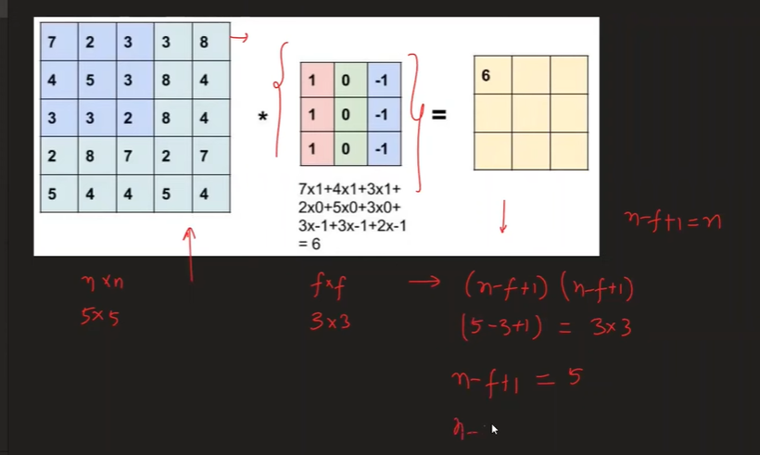

- Types:
  - Valid padding → no padding (output smaller).
  - Same padding → padding added so output = input size.
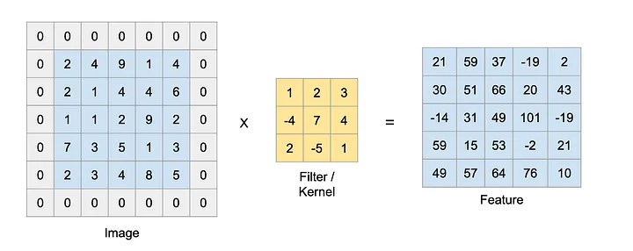

(c) Stride
- Number of steps kernel moves each time.
- The stride value defines how many pixels the filter shifts (or "steps") across the input image after each convolution operation.
- Stride = 1 → detailed scanning.
- Stride > 1 → faster, reduces output size.
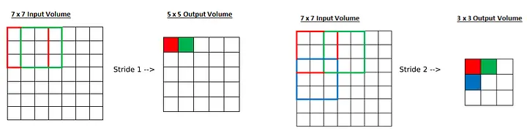
- Using a stride greater than one is sometimes called "strided convolution".
- There are two primary reasons for using strided convolution:
  - 1. Focusing on High-Level Features:
    - A small stride (e.g., 1) captures fine details or "low-level features" in an image.
    - A larger stride causes the CNN to "jump through" information, essentially skipping many pixels.
    - This results in the CNN capturing only "high-level" or "coarse" features, which might be sufficient or desired for certain computer vision problems.
  - 2. Reducing Computational Power/Speeding up Training:
    - A larger stride means fewer convolution operations are performed.
    - This can significantly speed up the training process, especially for very large datasets.
    - Note: This reason has become less critical in recent years due to increased computing power, so many models now often use a default stride of 1. However, strides are still relevant for specific problems.

(d) Activation Function (ReLU)
- After convolution, apply non-linearity (e.g., ReLU).
- (\text{ReLU}(x) = \max(0, x))
- Helps CNN learn complex, non-linear patterns.

(e) Pooling Layer
- Reduces spatial size (downsampling).

2. Why Pooling is Necessary: Problems it Solves
Before understanding the pooling operation, it's important to understand its necessity within a CNN. When applying a convolution operation, two main problems arise:
Problem 1: Memory Issues
- Convolution operations can require a significant amount of memory, potentially causing a program to crash.
- Example: For an input image of 228x228x3 (standard for many good CNN architectures) and applying 100 filters of 3x3x3, the resulting feature map would be 226x226x100.
- If these numbers are stored using 32-bit floating-point values, this single training data point would occupy around 900 MB of RAM.
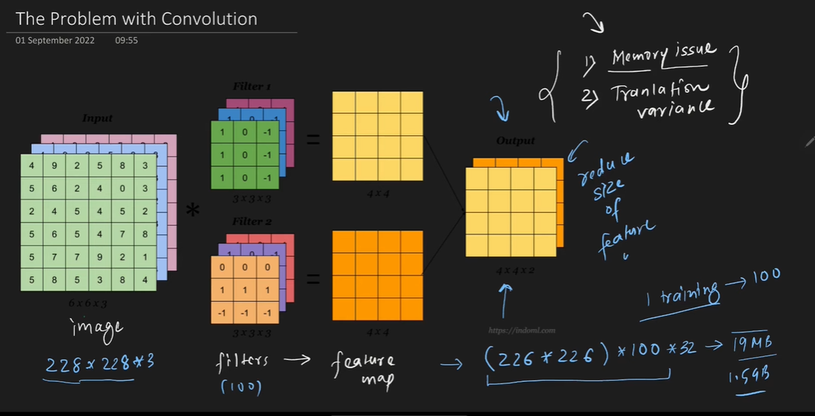
- For a batch size of 4, this could amount to approximately 1.5 GB.
- Conclusion: Such large feature maps are not sustainable, necessitating a reduction in their size.
- One possible solution is to increase the stride in convolution, which automatically reduces the feature map size, but pooling is generally preferred because it also addresses the second problem.
Problem 2: Translation Variance
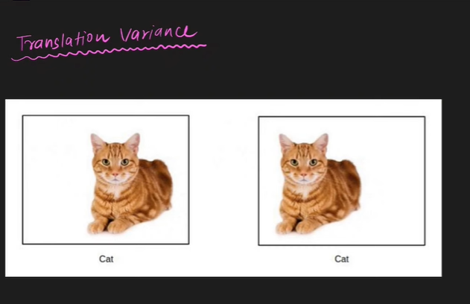
- Convolution operations exhibit translation variance.
- A convolution operation's purpose is to detect features (e.g., eyes, nose, tail of a cat) in images.
- The problem is that the features detected by the CNN become location-dependent.
  - Example: If a cat's ear is on the left side of the image, features will be detected there. If it shifts to the right, features will be detected on the right.
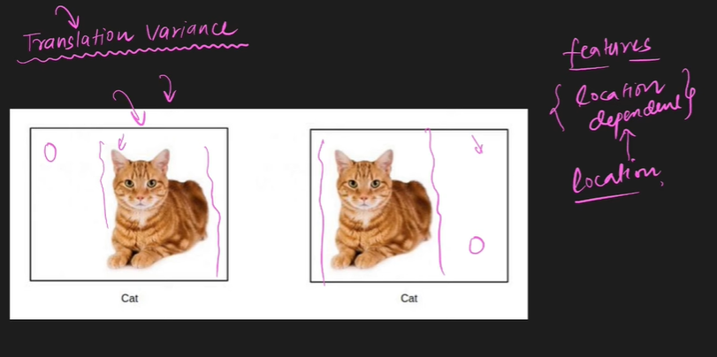
- In image classification tasks (e.g., identifying a cat), the location of a feature does not matter; what matters is the presence of the feature itself.
- If features are location-dependent, subsequent layers might treat the same feature in different locations as distinct, leading to incorrect results.
- Desired outcome: Translation Invariance, meaning that the location of a feature does not affect its identification or treatment by the model. Pooling helps achieve this.
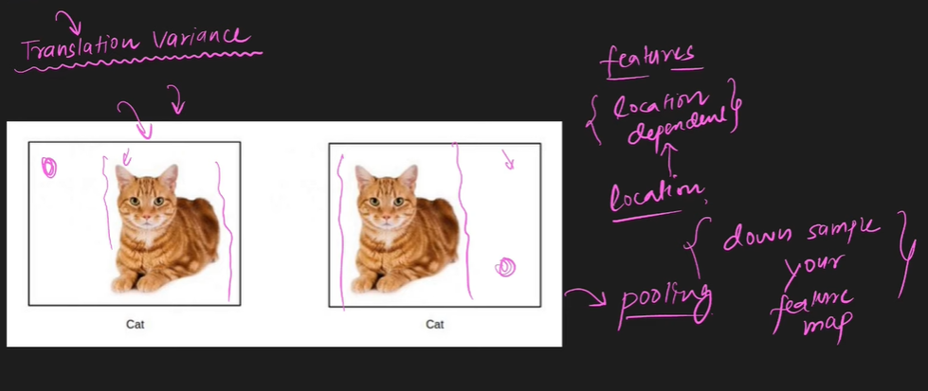
Types of Pooling Operations:
- Max Pooling (most famous and commonly used).
- Mean Pooling.
- Average Pooling.
- L2 Pooling.
- Global Pooling.
How Max Pooling Works (Detailed Example):
- Suppose you have a 4x4 feature map with numbers.
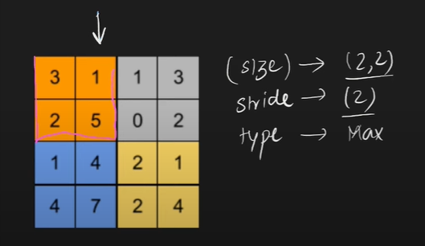
- To apply a pooling operation, you specify three things:
  - Window Size: Typically 2x2, but can be changed.
  - Stride: Typically 2, but can be changed.
  - Type of Pooling: e.g., Max Pooling.
- Enhances Features (Specific to Max Pooling).

  - Max Pooling works by extracting the most dominant features from a local receptive field.
  - This process can result in a feature map where the detected features appear more pronounced or "bright". Other pooling types like Mean Pooling do not offer this specific advantage.

- Example: 2×2 max pooling reduces a 4×4 feature map → 2×2.
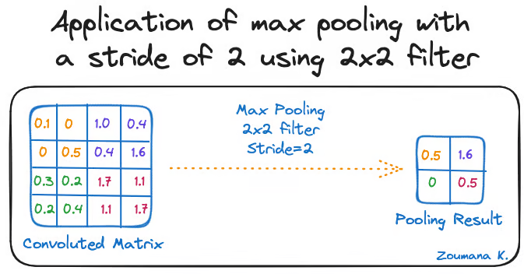
👉 Reduces computation + prevents overfitting.

8. Disadvantages of Pooling
While beneficial, pooling has its drawbacks:
- Not Suitable for All Tasks (Location Matters).
  - The translation invariance provided by pooling is excellent for image classification (where "cat or not cat" is the question, not "where is the cat?").
  - However, for tasks like image segmentation (dividing an image into distinct regions), the location of features is crucial. In such cases, pooling may not be used as extensively.
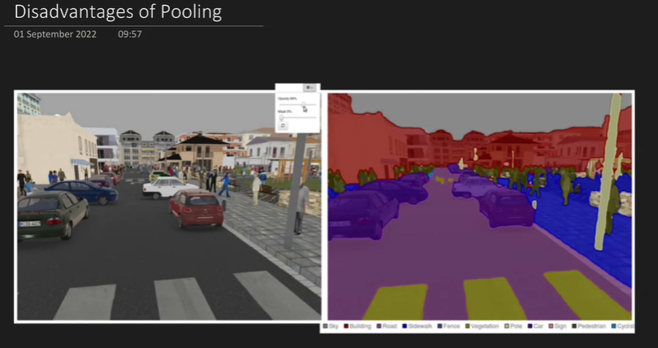
- Loss of Information.
  - Pooling is a downsampling operation that discards a significant amount of data.
  - Example: Reducing a 4x4 feature map to 2x2 means you are retaining only 4 out of 16 values, effectively losing about 75% of the information.
  - Whether this information loss is detrimental or acceptable depends on the specific application being built.
  - It's worth noting that some research papers have shown that respectable accuracies can be achieved in CNNs even without pooling, relying solely on convolutional layers.

(f) Flattening
- Converts 2D feature maps into a 1D vector before feeding into fully connected layers.
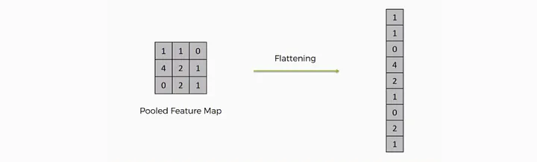

(g) Fully Connected Layer (Dense Layer)
- After feature extraction, fully connected layers combine features to classify images (softmax for multi-class).
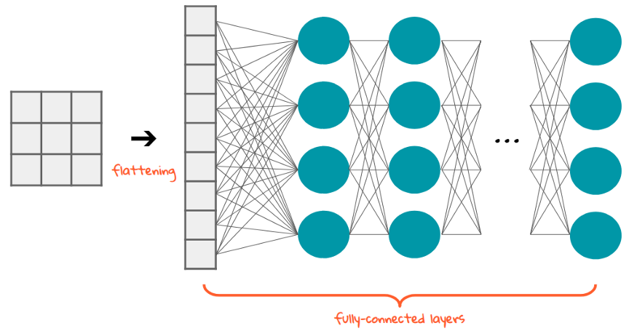

(h) Dropout
- Randomly deactivates neurons during training.
- Prevents overfitting.
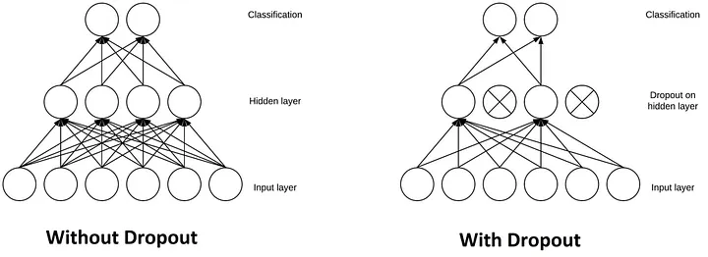
https://stanford.edu/~shervine/teaching/cs-230/cheatsheet-convolutional-neural-networks

4. 📐 CNN Architecture Example
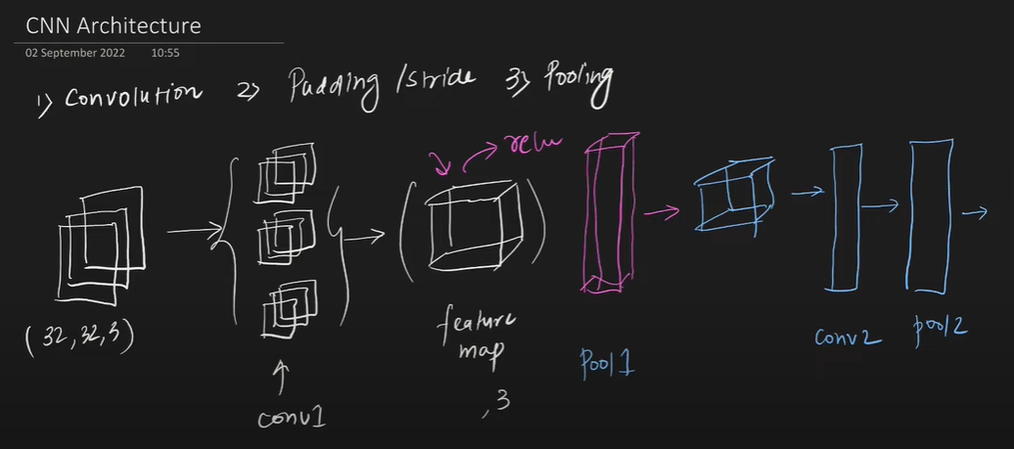
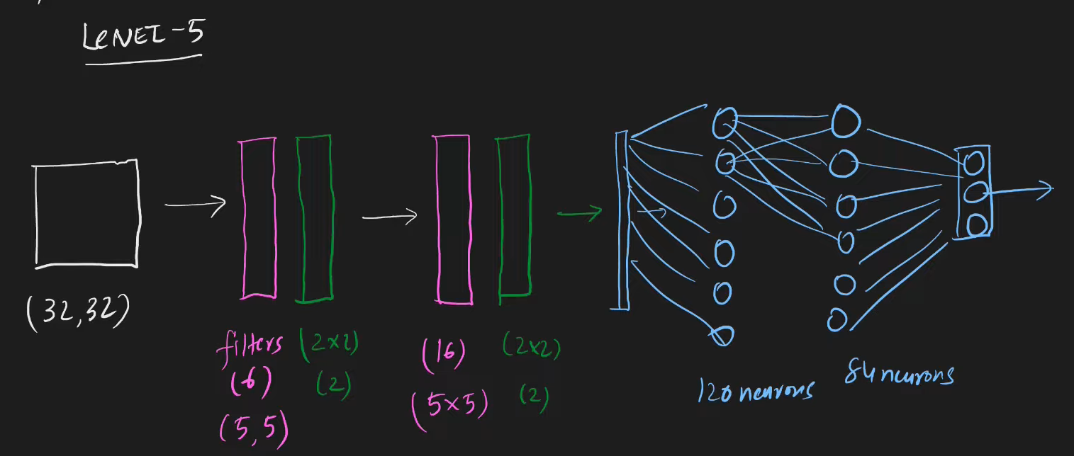
For a 32×32 RGB image:
- Input: (32 \times 32 \times 3)
- Conv Layer (5×5 filters, 6 filters): (28 \times 28 \times 6)
- Pooling Layer (2×2): (14 \times 14 \times 6)
- Conv Layer (5×5 filters, 16 filters): (10 \times 10 \times 16)
- Pooling Layer: (5 \times 5 \times 16)
- Flatten: (400)
- Fully Connected Layer: 120 → 84 → 10 (classes)
👉 This is similar to LeNet-5 (one of the first CNNs).

5. 🧮 Key Concepts in CNN
- Receptive Field: Region of input influencing one neuron in feature map.
- Feature Hierarchy:
  - Early layers → edges, corners.
  - Middle layers → textures, shapes.
  - Later layers → objects.
- Parameter Sharing: Same filter weights reused → efficient.
- Translation Invariance: CNN detects objects regardless of their location.
Key Concepts
- Filters (Kernels)
- : These are small matrices that are learned during the training process to detect specific features in the input data.
- Feature Maps
- : The output of the convolution operation, highlighting the presence of specific features within the input image.
- Automatic Feature Extraction
- : Unlike traditional algorithms where filters are manually engineered, CNNs learn the optimal filters automatically from the data.
- Spatial Hierarchy
- : CNNs process information hierarchically, from simple features in early layers to complex patterns in deeper layers, much like the human brain.

- History:
  - 1998: Yann LeCun developed the first successful convolutional network at AT&T Labs.
  - Application: This early CNN was capable of scanning checks and identifying handwritten digits.
  - Subsequent Developments: Following this, Microsoft developed various OCR (Optical Character Recognition) and handwriting recognition tools, which significantly boosted research in CNNs.
  - Modern Day: Today, CNNs are one of the most popular and successful neural networks available. They are integral to applications ranging from facial recognition software to self-driving cars. Their impact on society is profound due to their successful real-world implementations.

7. ✅ Advantages of CNN
- Captures spatial features (edges → patterns → objects).
- Fewer parameters vs fully connected networks.
- Translation and distortion invariant.
- State-of-the-art in computer vision.

8. ❌ Disadvantages of CNN
- Computationally expensive (needs GPUs/TPUs).
- Requires large labeled datasets.
- Limited interpretability (black box).
- Vulnerable to adversarial attacks.

9. 📌 Applications of CNN
- Image classification (dogs vs cats, medical images).
- Object detection (YOLO, Faster R-CNN).
- Face recognition (security, social media).
- Medical imaging (tumor detection).
- Autonomous vehicles (road sign detection).
- Natural language processing (sentence classification, text matching).

7. Applications of CNNs
CNNs are extremely popular and widely applied across a diverse range of problems:
- Image Classification: Categorizing a given image into one of several predefined classes.
  - Example: Determining if an image contains a cat or a dog, or identifying specific objects like a container ship, motor scooter, or leopard.
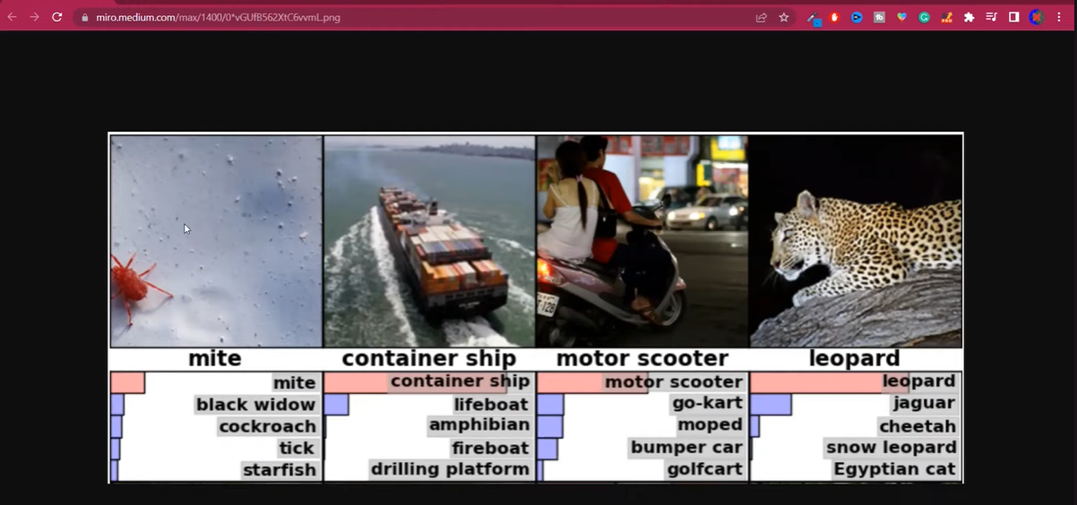
- Object Localisation: Identifying the presence and exact location of a specific object within an image by drawing a rectangular bounding box around it.
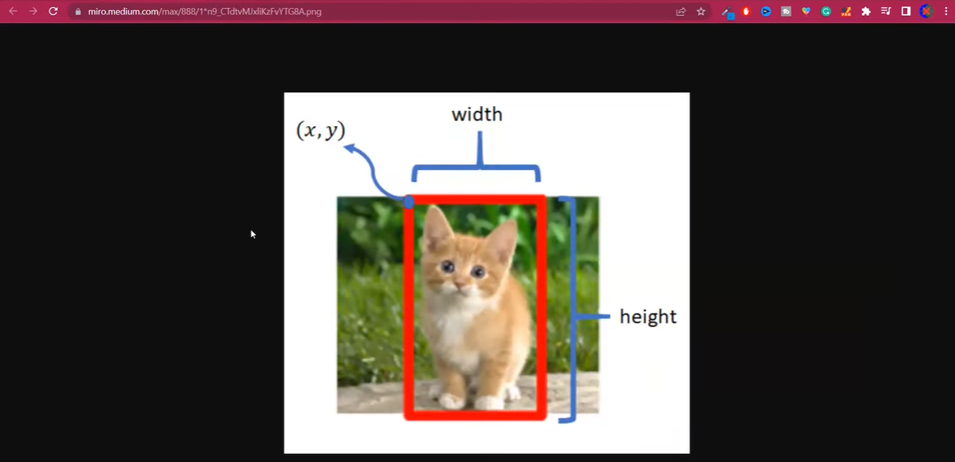
- Object Detection: A more complex task that involves identifying all objects within an image, locating them with bounding boxes, and also providing a probability score indicating the confidence of detection.
  - Example: Crucial for technologies like self-driving cars to detect pedestrians, other vehicles, and traffic signs.
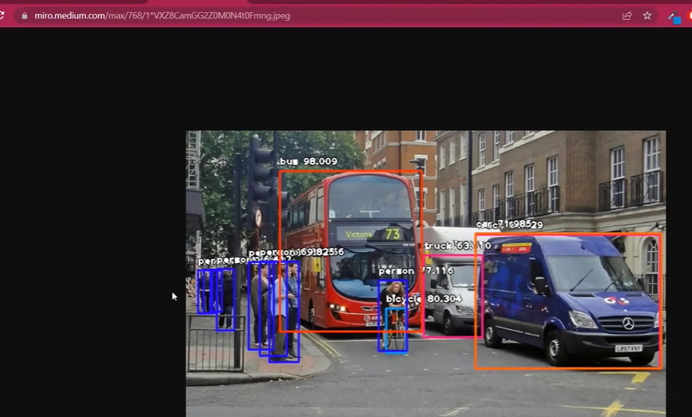
- Face Detection and Recognition:
  - Example: Used in modern smartphone cameras for unlocking devices or applying effects.
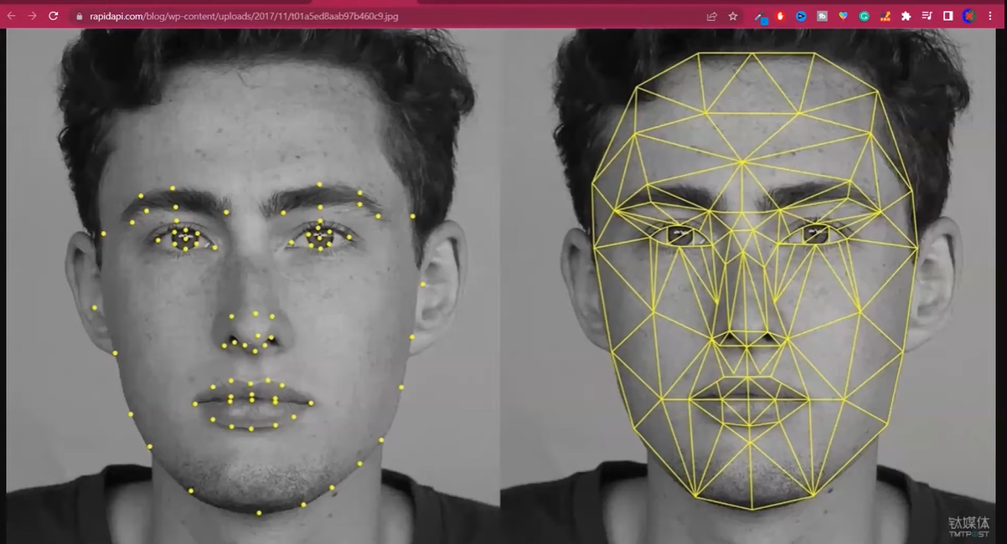
- Image Segmentation: Dividing an image into multiple segments or regions, often based on semantic meaning.
  - Example: Separating a tiger from its background in an image, useful for further image processing or analysis.
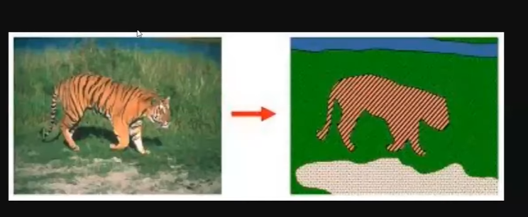
- Super-Resolution: Enhancing the quality and increasing the resolution of low-resolution images.
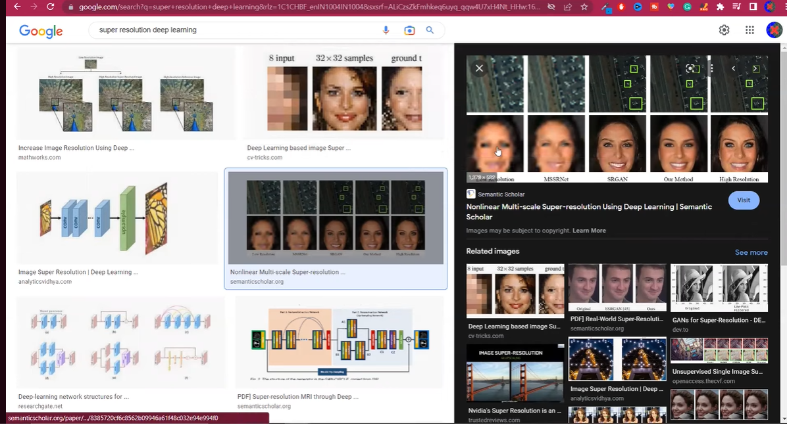
- Image Colorisation: Converting black-and-white photos or videos into color.
  - Example: Reviving old family photos or classic movies by adding color.

- Pose Estimation: Detecting the current pose of a human body from a camera feed.
  - Example: Used in fitness applications to track exercise movements (e.g., yoga poses) or in gaming consoles like Microsoft Kinect or PlayStation for interactive gameplay.
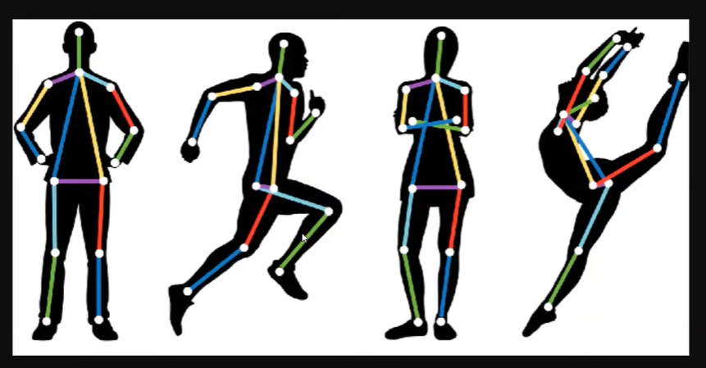

—----------------------------------------------------------------------------------------------------------------------

6. 📊 Famous CNN Architectures
- LeNet-5 (1998) → Handwritten digits.
- AlexNet (2012) → ImageNet competition, deeper CNN, ReLU, dropout.
- VGGNet (2014) → Small 3×3 filters, very deep.
- GoogLeNet (Inception, 2014) → Inception modules, parallel filters.
- ResNet (2015) → Skip connections (solves vanishing gradient).
- EfficientNet (2019) → Scales depth, width, resolution efficiently.
- InceptionNet

Transfer Learning: An important concept involving the use of pre-trained models

10. 🧑‍💻 Python Example (Keras CNN)
import tensorflow as tf
from tensorflow.keras import datasets, layers, models

# Load CIFAR-10 dataset
(x_train, y_train), (x_test, y_test) = datasets.cifar10.load_data()
x_train, x_test = x_train / 255.0, x_test / 255.0 # Normalize

# Build CNN
model = models.Sequential([
layers.Conv2D(32, (3,3), activation='relu', input_shape=(32,32,3)),
layers.MaxPooling2D((2,2)),
layers.Conv2D(64, (3,3), activation='relu'),
layers.MaxPooling2D((2,2)),
layers.Conv2D(64, (3,3), activation='relu'),
layers.Flatten(),
layers.Dense(64, activation='relu'),
layers.Dense(10, activation='softmax')
])

# Compile & Train
model.compile(optimizer='adam', loss='sparse_categorical_crossentropy', metrics=['accuracy'])
model.fit(x_train, y_train, epochs=10, validation_data=(x_test, y_test))

# Evaluate
test_loss, test_acc = model.evaluate(x_test, y_test)
print(f"Test Accuracy: {test_acc:.2f}")

✅ This is a complete CNN overview: intuition, math, components, architectures, advantages, disadvantages, applications, and example code.
Would you like me to also create a step-by-step diagrammatic flow (with visuals) of CNN operations (Convolution → ReLU → Pooling → Flatten → Dense) for easier teaching?

Project: Cat Vs Dog Image Classification Project | Deep Learning Project | CNN Project
https://www.kaggle.com/datasets/salader/dogsvscats
class 10 cnn_project_cat_vs_dog.ipynb
1. Project Overview and Introduction
- Goal: To build a Dog vs Cat Classifier using a Convolutional Neural Network (CNN) model.
- Functionality: The model should classify an input photo as either containing a dog or a cat.
- Learning Context: This project continues the deep learning playlist, applying concepts like CNNs and backpropagation.
- Approach:
  - All code will be written from scratch.
  - A custom CNN architecture will be built.
  - Discussion on how to improve model performance if it's not good.
  - Demonstration of predictions on unseen data.
- Recommendation: Viewers are encouraged to code along for better understanding.
2. Data Acquisition and Initial Setup
- Dataset Source: Kaggle's "Dogs vs Cats" dataset.
- Dataset Structure:
  - Downloaded as a ZIP file.
  - Unzips into two main folders: test and train.
  - Each of these folders further contains cats and dogs subfolders, organising images by class.
- Tools & Environment:
  - Keras: Used for the entire CNN classification task.
  - Google Colab: Recommended for development, especially if a local machine lacks a GPU, which is crucial for faster training.
- Setting up Kaggle API in Google Colab (for data download):
  - Question: How to get the data into Google Colab efficiently?
  - Solution: Use the Kaggle API directly in Colab.
    - Navigate to your Kaggle account and download the kaggle.json file.
    - Upload this kaggle.json file to your Google Colab environment.
    - From the Kaggle dataset page, copy the API command.
    - Run specific commands in Colab:
      - Two preliminary commands are needed before the API command (exact commands not transcribed, but implied for setting up Kaggle environment).
      - Execute the copied Kaggle API command to download the dataset.
  - Benefit: This method avoids downloading to local machine and then uploading to Colab, which is time-consuming for large datasets.

============================================================================================================================================

What is Transfer Learning
1 Deep Learning and its Challenges
- Deep Learning models are data-hungry, requiring a large amount of labelled data for training (e.g., 10,000 images).
- Collecting such data can involve scraping images, but labelling each image is difficult, requires manual labour, and is costly for companies.
- Training Deep Learning models, especially on large datasets, takes a significant amount of time.
- Due to these problems (data requirements and training time), people generally do not prefer to train their own Deep Learning models from scratch.
2. Pre-trained Models as a Solution
- The solution to the challenges of training custom models is using pre-trained models.
- The source refers to a previous video that discussed ImageNet, a very large dataset of daily objects and animals, containing around 1.4 million images across 1000 categories (e.g., different dog breeds).
- An annual competition called ILSVRC (ImageNet Large Scale Visual Recognition Challenge) was organised on the ImageNet dataset.
- Models like VGG, ResNet, and InceptionNet emerged from this competition, demonstrating high performance after being trained on ImageNet.
- Pre-trained models are CNN models trained on a different, large dataset (like ImageNet). They have "learned" from this previous large dataset and can be used in other projects.
3. The Problem with Pre-trained Models and the Emergence of Transfer Learning
- A potential problem with pre-trained models is that the specific classes required for a new project might not be present in the 1000 classes the model was originally trained on.
- For example, if a project requires classifying images as "phone" or "tablet," and these specific classes are not among ImageNet's 1000 classes, directly using the pre-trained model might not work.
- Transfer Learning is introduced as the solution to this problem.
4. What is Transfer Learning?

- Transfer Learning is a machine learning technique that focuses on storing knowledge gained while solving one problem and applying it to a different but related problem.
- It leverages the benefits of pre-trained models by using a CNN trained on another dataset (which saves cost and time on data collection and training).
- Transfer Learning has become a significant area in machine learning since 2015-2016.
- Andrew Ng stated that, besides supervised learning, Transfer Learning will be the next big thing to advance machine learning in the industry, even surpassing unsupervised and reinforcement learning in potential impact.
- Transfer Learning is inspired by real-life situations:
  - Learning to ride a bicycle makes learning to ride a motorcycle easier because the brain transfers balancing knowledge.
  - Knowing how to play a musical instrument like the violin makes learning a related instrument like the guitar easier due to an understanding of musical notes.
- In essence, Transfer Learning is the computer science integration of this idea: applying knowledge from one domain to another.
- class 14 What is Transfer Learning? Transfer Learning in Keras | Fine Tuning Vs Feature Extraction
- class 14.3 transfer_learning_finetuning.ipynb

======================================================================
https://www.datacamp.com/tutorial/introduction-to-convolutional-neural-networks-cnns
https://www.geeksforgeeks.org/machine-learning/introduction-convolution-neural-network/
https://medium.com/@draj0718/convolutional-neural-networks-cnn-architectures-explained-716fb197b243

